# MWANZO BARAKA MANAGEMENT INFORMATION SYSTEM



**NAME: BENSON GITHUTHA**

**SCHOOL: STAREHE BOYS CENTRE AND SCHOOL**

**INDEX NO: 20400004108**

**PRESENTED TO: KENYA NATIONAL EXAMINATION COUNCIL**

**YEAR: 2017**

# DECLARATION

I declare this computerized system as an original project created by me, the system analyst, for the benefit of Mwanzo Baraka Organization.

System Developer

Benson Githutha.

# DEDICATION

I dedicate this project to:

* My School, Starehe Boys’ Centre
* My guardians; Mr. and Mrs. Kariuki and my sister Lucy Muthoni.
* My teachers at Starehe Boys’ Centre and School

# TABLE OF CONTENTS

MWANZO BARAKA MANAGEMENT INFORMATION SYSTEM 1

DECLARATION i

DEDICATION ii

TABLE OF CONTENTS iii

LIST OF TABLES vi

LIST OF FIGURES vii

ACKNOWLEDGEMENT ix

INTRODUCTION x

CHAPTER ONE: SYSTEM INVESTIGATION AND ANALYSIS 1

Problem definition 1

Overview of exiting system 1

Proposed system 2

Objectives of the proposed system 2

Scope of the proposed system 2

Advantages of the proposed system 2

Disadvantages of the proposed system 2

Feasibility Study 3

Technical Feasibility 3

Legal Feasibility 3

Schedule Feasibility 3

Economic Feasibility 3

Social Feasibility 4

Assumptions 4

Justification of the new system 4

Fact finding 4

Observation 4

Interviews 4

Document Analysis 4

CHAPTER TWO: SYSTEM DESIGN 5

Table Design 5

Appropriate Variables and Data Types 5

Grouping of Variables into Tables 10

Input Screens 12

Output Screens 15

Block Diagram 17

System Flowchart 18

CHAPTER THREE: SYSTEM CONSTRUCTION 19

Modular Flowcharts 19

Relationships 24

Process specifications 24

Output specifications 24

Tables 25

Input Screens/Forms 30

Output Screens 40

CHAPTER FOUR: SYSTEM TESTING AND DEMONSTRATION 42

Objectives of the testing 42

Data Testing Approaches 42

By Dry Running 42

By Use of Compilers 42

By Use of Test Data 42

By Use of Actual Data 42

Data Validation Approaches 42

Black Box Testing 42

White Box Testing 42

Data testing plan 43

CHAPTER FIVE: USER MANUAL 44

Hardware Specifications 44

Software Specifications 44

System loading and installation process 44

System loading process 45

Navigation guide 45

Procedure for generating output 46

System security and control measures 46

System changeover 47

Error handling 48

CONCLUSION 49

RECOMMENDATIONS 50

BIBLIOGRAPHY 51

APPENDICES 52

APPENDIX I: SYMBOLS USED 52

APPENDIX II: DEFINITION OF TERMS 53

APPENDIX III: SYSTEM CODING 54

# LIST OF TABLES

Table 1: Economic Feasibility 3

Table 2: Members Table 5

Table 3: Individual Details Table 5

Table 4: Groups Table 6

Table 5: Members Table 6

Table 6: Individual Monthly Contributions Table 6

Table 7: Group Members Monthly Contributions Table 6

Table 8: Individual Member Loan Table 7

Table 9: Group Member Loan Table 7

Table 10: Group Loan Table 7

Table 11: Individual Payments Table 7

Table 12: Group Member Payments Table 8

Table 13: Group Payments Table 8

Table 14: Individual Member Defaulted Payments Table 8

Table 15: Group Member Defaulted Payments Table 8

Table 16: Group Defaulted Payments Table 9

Table 17: Users Table 9

Table 18: Members Table 10

Table 19: Groups Table 10

Table 20: Individual Details Table 10

Table 21: Individual Monthly Contributions Table 11

Table 22: Individual Member Loans Table 11

Table 23: Users Table 11

Table 24: Members Report 15

Table 25: Individual Members’ Loans Report 15

Table 26: Individual Members’ Monthly Contributions Report 16

Table 27: Individual Members’ Payments Report 16

Table 28: Testing text Data Types 43

Table 29: Testing Date/Time Data Type 43

Table 30: Testing Currency Data Type 43

Table 31: Flowchart symbols 52

Table 32: Prefixes of controls 53

# LIST OF FIGURES

Figure 1: Log In Form 12

Figure 2: Members Form 12

Figure 3: Individual Members Registration Form 13

Figure 4: Group Members Registration Form 13

Figure 5: Individual Members Contributions Form 14

Figure 6: Block Diagram 17

Figure 7: System Flowchart 18

Figure 8: Log In Flowchart 19

Figure 9: Previous Record Flowchart 20

Figure 10: Next Record flowchart 21

Figure 11: Add Record flowchart 22

Figure 12: Save Record Flowchart 23

Figure 13: Relationships 24

Figure 14: Members Table 25

Figure 15: Individual Details Table 26

Figure 16: Groups Table 26

Figure 17: Group Members Table 26

Figure 18: Individual Members Monthly Contributions Table 27

Figure 19: Group Members Monthly ContributionsTable 27

Figure 20: Individual Member Loan Table 28

Figure 21: Group Member Loan Table 28

Figure 22: Group Loan Table 28

Figure 23: Individual Members Payments Table 28

Figure 24: Group Member Payments Table 29

Figure 25: Group Payments Table 29

Figure 26: Individual Member Defaulted Payments Table 29

Figure 27: Group Member Defaulted Payments Table 29

Figure 28: Group Defaulted Payments Table 30

Figure 29: Users Table 30

Figure 30: Log in Form 31

Figure 31: Splash Form 31

Figure 32: Switchboard 32

Figure 33: Members Form 32

Figure 34: Group Members Form 33

Figure 35: Group Details Form 33

Figure 36: Individual Registration Form 34

Figure 37: Group Registration Form 34

Figure 38: Individual Monthly Contributions Form 35

Figure 39: Group Member Monthly Contributions Form 35

Figure 40: Group Share Contributions Form 36

Figure 41: Individual Loan Form 36

Figure 42: Group Member Loan Form 37

Figure 43: Group Loan 37

Figure 44: Individual Payments Form 38

Figure 45: Group Member Payments Form 38

Figure 46: Group Payments Form 39

Figure 47: Members Report 40

Figure 48: Individual Members Monthly Contributions Report 40

Figure 49: Individual Members Loans Report 41

Figure 50: Individual Members Payments Report 41

# ACKNOWLEDGEMENT

I am very grateful for all the support and guidance through my project.

I would first like to acknowledge my school, Starehe Boys’ Centre and School for providing me with the required resources and knowledge to accomplish and complete this project. My teacher, Mr.Ndede has guided me on what to do and due to his faith in me, I am able to do this project. My regards also go to my friends for their support that helped me in the perfection of my project. Finally, I would like to thank my parents who have corrected and supported me during the development of my project.

# INTRODUCTION

Mwanzo Baraka organization is a self-help group that is intended to improve the economic status of its members via pooling of financial resources. This benefits the members because they are privileged to get cheap loans from the organization.

The organization sustains itself through: Registration fees of its members, Monthly contributions, Interest gained through loans given to members and Penalties of delayed payments.

The organization is an open group and therefore anyone is free to join it provided he adheres to the rules.

Since the group was established they have been conducting their operations manually. It has been undergoing difficulties in recording, updating and accessing of records. Also, carrying out the calculations required manually has been very cumbersome. Due to this, the management of the group has called for the computerization of their operations and that is exactly what they entrusted me to do.

# CHAPTER ONE: SYSTEM INVESTIGATION AND ANALYSIS

## Problem definition

Problem definition is a stage whereby an outline of the problems facing the current manual system is outlined. Some of the problems facing the manual system are:

* They use 2 register books to record names of members (both Individual and Group Members) and groups together with their registration fees.
* They use 2 record books to record and maintain the monthly contributions of the members whether registered as an Individual or in a Group.
* They use cashbooks to record the loans offered, the normal loan payments and the payments for penalized defaulted amounts.
* They calculate interests gained by the organization, penalties, income for the organization and dividends manually.
* They give out receipt statements manually.

## Overview of exiting system

**Advantages of the existing system**

* The data is original.
* Creates job opportunities especially in the accounting sector.
* The system is easy to understand.
* Use of register books, record books and cashbooks is much cheaper compared to buying and maintenance of computers and the information management software.
* Freedom from machines for one can carry out the calculations at any place other than at the office.

**Disadvantages of the existing system**

* There is data redundancy.
* Accessing of records is tedious and time wasting.
* There is difficulty in tracking incomplete payments, monthly contributions and payments for penalized amounts.
* Errors in allocating of Member numbers, Individual numbers, Group IDs and Loan IDs.
* Wrong data entry.
* Producing financial statements is exhausting and time wasting.
* Insecurity of the files because they are being stored in shelves and lockers whose keys can easily get lost or can be stolen by unauthorized people who want to have access to the data in the files.
* Calculating dividends and shares is tedious and there are many errors in the calculations.

## Proposed system

### Objectives of the proposed system

The proposed system will be fully computerized and will require the use of a computer in carrying all of its operations.

The objectives of this proposed system include:

* To reduce the cost of frequently buying register books, record books and cashbooks.
* Efficient and fast data processing.
* Provision of accurate and more informative statements and receipts.
* Safety of the organization’s files and data.

### Scope of the proposed system

The proposed system will be able to do the following:

* It will maintain all members’ and groups’ records.
* It will be able to calculate interests, payments, penalties and dividends automatically at an instant when the records are updated.
* It will be able to produce accurate reports and receipt statements.

### Advantages of the proposed system

* Enhanced speed of carrying out calculations.
* The files are secure due to use of passwords to have access to their data.
* Automation of tasks.
* It is cheaper to run.
* Tracking of members’ contributions, loans and payments is easier.

### Disadvantages of the proposed system

* Implementation and maintenance of the proposed system is expensive.
* There must be a constant and reliable source of power.
* User training is a requirement before using the proposed system.
* Resistance from staff who are likely to be lose their jobs or become displaced when the system is implemented.
* There will be a high dependency on the computers for carrying out the organization’s activities.

## **Feasibility Study**

It is a study that is conducted when developing a system to determine if the project should be carried out or not. Therefore, the following are the feasibility studies that were carried out on both the existing and proposed system.

### Technical Feasibility

The hardware, software and the technology required to develop, install, maintain and run the system is locally and readily available.

### Legal Feasibility

The proposed system will not violate any law. It is original and approved by the organization’s administrators.

### Schedule Feasibility

The development and implementation of the proposed system shall be done in 4 phases so as to get used to it and so that all the records can be captured by the new system. The system will be complete in 4 months.

Time allocated for the implementation is as follows:

* System Investigation and Analysis………………..3 weeks
* System Design…………………………………….1 month 1 week
* System Construction……………………………....1 month
* System Testing and Demonstration……………….1 month

### Economic Feasibility

This is carried out so as to determine if the cost of introducing the new system is affordable. The organization then uses this to find out if it is able to realize large profits using the new system as compared to the old system.

|  |  |
| --- | --- |
| **Requirements** | **Cost** |
| 3 Computers @Kshs. 45,000  512 MB RAM,80GB,HDD,OS,Monitor, Keyboard, Mouse | Kshs. 135,000 |
| 2 Inkjet Printers | Kshs. 20,000 |
| Staff Training | Kshs. 20,000 |
| Software Antivirus, Mwanzo Baraka Software | Kshs. 50,000 |
| Electricity per month | Kshs. 5,000 |
| **Totals** | **Kshs. 230, 000** |

Table 1: Economic Feasibility

### Social Feasibility

It is concerned with the effects on the employees and customers at the introduction of the new system .The system was approved and well welcomed by the employees.

## Assumptions

There will be no delays in collecting and analyzing of data.

## Justification of the new system

After the feasibility study and comparing the advantages and disadvantages of the existing and proposed system, it is evident that this proposed system will be a success because its advantages are more.

## Fact finding

Information about the operations of the system was collected through:

* Observation
* Interviews
* Document Analysis

### Observation

First-hand information of how members are registered, how the monthly contributions are recorded, how loans and payments are issued out and how the organization’s income and dividends are calculated was collected by me.

### Interviews

I carried out interviews with the staff working for the organization, the management and also the members registered in the organization. This helped me know the weaknesses and the strengths of the existing system.

### Document Analysis

Study of the documents used in the system; record books, register books, cashbooks were carried out. The calculations and how records were entered were noted down.

# CHAPTER TWO: SYSTEM DESIGN

This is a stage in system development where the actual creating of the database structure is done. Several tools e.g. table designs, block diagrams and system flowcharts are used to assist in achieving the framework of the system.

## Table Design

### Appropriate Variables and Data Types

The tables that are to be used in creating the database are as follows:

**Members Table**

|  |  |
| --- | --- |
| **Field Name** | **Data Type** |
| National ID No | Text |
| Member No | Text |
| First Name | Text |
| Last Name | Text |
| Gender | Text |
| Mobile No | Text |
| Email Address | Text |
| Place of Residence | Text |
| Date of Birth | Date/Time |
| Registration Type | Text |

Table 2: Members Table

**Individual Details Table**

|  |  |
| --- | --- |
| **Field Name** | **Data Type** |
| Individual No | AutoNumber |
| Member No | Text |
| Registration Type | Currency |
| Date of Registration | Date/Time |

Table 3: Individual Details Table

**Groups Table**

|  |  |
| --- | --- |
| **Field Name** | **Data Type** |
| Group ID | Text |
| Group Name | Text |
| Registration Fee | Currency |
| Name of Group Official | Text |
| Group Official Telephone No | Text |
| Date Of Registration | Date/Time |

Table 4: Groups Table

**Group Members Table**

|  |  |
| --- | --- |
| **Field Name** | **Data Type** |
| Member No | Text |
| Group Name | Text |
| Group ID | Text |

Table 5: Members Table

**Individual Monthly Contributions Table**

|  |  |
| --- | --- |
| **Field Name** | **Data Type** |
| Member No | Text |
| Individual No | Text |
| Individual Contribution | Currency |
| Date of Contribution | Date/Time |

Table 6: Individual Monthly Contributions Table

**Group Members Monthly Contributions Table**

|  |  |
| --- | --- |
| **Field Name** | **Data Type** |
| Member No | Text |
| Group ID | Text |
| Total Money Contributed | Currency |
| Group Share Contribution | Currency |
| Group Member Contribution | Calculated |
| Date Of Contribution | Date/Time |

Table 7: Group Members Monthly Contributions Table

**Individual Member Loan Table**

|  |  |
| --- | --- |
| **Field Name** | **Data Type** |
| Loan ID | AutoNumber |
| Member No | Text |
| Individual No | Text |
| Amount Loaned | Currency |
| Due Payment Date | Date/Time |
| Date Borrowed | Date/Time |
| Loan Issued Out | Text |

Table 8: Individual Member Loan Table

**Group Member Loan Table**

|  |  |
| --- | --- |
| **Field Name** | **Data Type** |
| Loan ID | Text |
| Member No | Text |
| Group ID | Text |
| Amount Loaned | Currency |
| Date Borrowed | Date/Time |
| Loan Issued Out | Text |
| Due Payment Date | Date/Time |

Table 9: Group Member Loan Table

**Group Loan Table**

|  |  |
| --- | --- |
| **Field Name** | **Data Type** |
| Loan ID | AutoNumber |
| Group ID | Text |
| Amount Loaned | Currency |
| Date Borrowed | Date/Time |
| Loan Issued Out | Text |
| Due Payment Date | Date/Time |

Table 10: Group Loan Table

**Individual Payments Table**

|  |  |
| --- | --- |
| **Field Name** | **Data Type** |
| Payment No | AutoNumber |
| Loan ID | Text |
| Member No | Text |
| Month Of Payment | Date/Time |
| Money Paid | Currency |
| Date of Payment | Date/Time |

Table 11: Individual Payments Table

**Group Member Payments Table**

|  |  |
| --- | --- |
| **Field Name** | **Data Type** |
| Payment No | AutoNumber |
| Loan ID | Text |
| Member No | Text |
| Month Of Payment | Date/Time |
| Money Paid | Currency |
| Date of Payment | Date/Time |

Table 12: Group Member Payments Table

**Group Payments Table**

|  |  |
| --- | --- |
| **Field Name** | **Data Type** |
| Payment No | AutoNumber |
| Loan ID | Text |
| Group ID | Text |
| Month Of Payment | Date/Time |
| Money Paid | Currency |
| Date of payment | Date/Time |

Table 13: Group Payments Table

**Individual Member Defaulted Payments Table**

|  |  |
| --- | --- |
| **Field Name** | **Data Type** |
| Payment No | AutoNumber |
| Loan ID | Text |
| Member No | Text |
| Money Paid | Currency |
| Date of Payment | Date/Time |
| Month Of Payment | Date/Time |

Table 14: Individual Member Defaulted Payments Table

**Group Member Defaulted Payments Table**

|  |  |
| --- | --- |
| **Field Name** | **Data Type** |
| Payment No | AutoNumber |
| Loan ID | Text |
| Member No | Text |
| Money Paid | Currency |
| Date of Payment | Date/Time |
| Month Of Payment | Date/Time |

Table 15: Group Member Defaulted Payments Table

**Group Defaulted Payments Table**

|  |  |
| --- | --- |
| **Field Name** | **Data Type** |
| Payment No | AutoNumber |
| Loan ID | Text |
| Group ID | Text |
| Money Paid | Currency |
| Date Of Payment | Date/Time |
| Month Of Payment | Date/Time |

Table 16: Group Defaulted Payments Table

**Users Table**

|  |  |
| --- | --- |
| **Field Name** | **Data Type** |
| User ID | AutoNumber |
| Name | Text |
| Organization Level | Text |
| Password | Text |

Table 17: Users Table

### Grouping of Variables into Tables

**Members Table**

|  |  |  |  |  |  |  |  |  |  |
| --- | --- | --- | --- | --- | --- | --- | --- | --- | --- |
| **National ID** | **Member No** | **First Name** | **Last Name** | **Gender** | **Mobile No** | **Email Address** | **Place of Residence** | **Date of Birth** | **Registration Type** |
| 10658794 | MB_001 | JAMES | MAINA | Male | (+254)722654982 | jamesmaina@gmail.com | Ruaraka | 24-08-92 | Individual Only |
| 20546887 | MB _002 | CHARLES | ODHIAMBO | Male | (+254)722984922 | charlesodhiambo@gmail.com | Kiambu | 06-09-90 | Both Individual and Group |
| 94458945 | MB_003 | MERCY | WAMAI | Female | (+254)795982989 | mercywamai@gmail.com | Komarock | 06-12-92 | None |

Table 18: Members Table

**Groups Table**

|  |  |  |  |  |  |
| --- | --- | --- | --- | --- | --- |
| **Group ID** | **Date of Registration** | **Group Name** | **Group Official** | **Group Official Tel. No** | **Registration Fee** |
| GP_001 | 12-01-17 | SIMBA | BEN KINYANJUI | (+254)751818915 | Kshs. 5000 |
| GP_002 | 28-01-07 | USHINDI | JANE WANJIKU | (+254)792829599 | Kshs. 5000 |
| GP_003 | 06-02-17 | AMANI | SARAH MUENI | (+254)748864886 | Kshs. 5000 |

Table 19: Groups Table

**Individual Details Table**

|  |  |  |  |
| --- | --- | --- | --- |
| **Individual No** | **Member No** | **Registration Fee** | **Date of Registration** |
| IND_001 | MB_001 | Kshs. 2000 | 10-01-17 |
| IND_002 | MB_005 | Kshs. 2000 | 13-01-17 |
| IND_003 | MB_002 | Kshs. 2000 | 28-02-17 |

Table 20: Individual Details Table

**Individual Monthly Contributions Table**

|  |  |  |
| --- | --- | --- |
| **Member No** | **Contribution** | **Date of Contribution** |
| MB_001 | Kshs.1220 | 12-01-17 |
| MB_001 | Kshs.1220 | 09-02-17 |
| MB_001 | Kshs.1000 | 16-03-17 |

**Table 21**: **Individual Monthly Contributions Table**

**Individual Member Loans Table**

|  |  |  |  |  |  |  |
| --- | --- | --- | --- | --- | --- | --- |
| **Loan ID** | **Member No** | **Individual No** | **Amount Loaned** | **Date Borrowed** | **Due Payment Date** | **Loan Issued out** |
| IMLN_001 | MB_002 | IND_003 | Kshs. 50,000 | 05-02-17 | August 2018 | Yes |
| IMLN_002 | MB_014 | IND_007 | Kshs. 20,000 | 19-12-18 | December 2018 | Yes |

Table 22: Individual Member Loans Table

**Users Table**

|  |  |  |  |
| --- | --- | --- | --- |
| **User ID** | **Name** | **Organization Level** | **Password** |
| USER_001 | Ivy Muthoni | Administrator | ***** |
| USER_002 | Samuel Moustapha | Administrator | ***** |
| USER_003 | Gladys Mwende | User | ***** |

Table 23: Users Table

## Input Screens

1. **Log In Form**

MWANZO BARAKA MANAGEMENT INFORMATION SYSTEM

Figure 1: Log In Form

Please Enter Your Password to log into the system

Name

Password

LOG IN

EXIT

1. **Members Form**

Previous Record

Next Record

Add Record

Save Record

EXIT

MWANZO BARAKA MANAGEMENT INFORMATION SYSTEM

Figure 2: Members Form

National ID

Member No

First Name

Last Name

Gender

Mobile No

Email Address

Place of Residence

Date of Birth

Registration Type

1. **Individual Members Registration Form**

Figure 3: Individual Members Registration Form

Save Record

MWANZO BARAKA MANAGEMENT INFORMATION SYSTEM

Member No

Individual No

First Name

Last Name

Registration Fee

Date of Registration

EXIT

1. **Group Members Registration Form**

Figure 4: Group Members Registration Form

Save Record

EXIT

MWANZO BARAKA MANAGEMENT INFORMATION SYSTEM

Group ID

Group Name

Name of Group Official

Group Official Tel No

Registration Fee

Date of Registration

1. **Individual Members Contributions Form**

Save Record

EXIT

MWANZO BARAKA MANAGEMENT INFORMATION SYSTEM

Figure 5: Individual Members Contributions Form

Member No

Amount of contribution

Date of Contribution

## Output Screens

1. **Members Report**

|  |  |  |  |  |  |  |  |  |  |
| --- | --- | --- | --- | --- | --- | --- | --- | --- | --- |
| MWANZO BARAKA MANAGEMENT INFORMATION SYSTEM | | | | | | | | | |
| **MEMBERS** | | | | | | | | | |
| **National ID** | **Member No** | **First Name** | **Last Name** | **Gender** | **Mobile No** | **Email Address** | **Place of Residence** | **Date of Birth** | **Registration Type** |
| 10658794 | MB_001 | JAMES | MAINA | Male | (+254)722654982 | jamesmaina@gmail.com | Ruaraka | 24-08-92 | Individual Only |
| 20546887 | MB _002 | CHARLES | ODHIAMBO | Male | (+254)722984922 | charlesodhiambo@gmail.com | Kiambu | 06-09-90 | Both Individual and Group |
| 94458945 | MB_003 | MERCY | WAMAI | Female | (+254)795982989 | mercywamai@gmail.com | Komarock | 06-12-92 | None |
| 26494518 | MB_004 | SARAH | MUENI | Female | (+254)748864886 | sarahmueni@gmail.com | Kayole | 8/5/1992 | Group Only |
| 15659491 | MB_005 | LUCY | MUTHONI | Female | (+254)738411289 | lucymuthoni1@gmail.com | Embakasi | 2/9/1995 | Individual Only |

Table 24: Members Report

1. **Individual Members’ Loans Report**

|  |  |  |  |  |  |  |  |  |
| --- | --- | --- | --- | --- | --- | --- | --- | --- |
| MWANZO BARAKA MANAGEMENT INFORMATION SYSTEM | | | | | | | | |
| **INDIVIDUAL MEMBERS LOANS** | | | | | | | | |
| **Loan ID** | **Member No** | **First Name** | **Last Name** | **Amount Loaned** | **Date Borrowed** | **Due Payment Month** | **Repayment Period(Months)** | **Was Loan Issued Out?** |
| IMLN_001 | MB_002 | CHARLES | ODHIAMBO | Kshs. 50,000 | 2/5/2017 | July 2018 | 17 | Yes |
| IMLN_002 | MB_014 | ELSIE | ATOTI | Kshs. 25,000 | 4/6/2017 | December 2018 | 20 | Yes |
|  |  |  |  | **Totals: 75,000** |  |  |  |  |

Table 25: Individual Members’ Loans Report

1. **Individual Members’ Monthly Contributions Report**

|  |  |
| --- | --- |
| MWANZO BARAKA MANAGEMENT INFORMATION SYSTEM | |
| **INDIVIDUAL MEMBERS MONTHLY CONTRIBUTIONS** | |
| Member No: MB_002 | |
| **Individual Contribution** | **Date of Contribution** |
| Kshs. 1000 | 1/12/2017 |
| Kshs. 1000 | 2/15/2017 |
| Kshs. 2000 | 3/16/2017 |
| Kshs. 1500 | 4/20/2017 |
| Kshs. 2000 | 5/10/2017 |
| Kshs. 1200 | 6/15/2017 |
| Kshs. 1050 | 7/20/2017 |
| **Totals : Kshs.9750** |  |

Table 26: Individual Members’ Monthly Contributions Report

1. **Individual Members’ Payments Report**

|  |  |  |  |  |
| --- | --- | --- | --- | --- |
| MWANZO BARAKA MANAGEMENT INFORMATION SYSTEM | | | | |
| **INDIVIDUAL MEMBER PAYMENTS** | | | | |
| Member No :MB_014 | | | | |
| Loan ID | Month Member Paid for | Money Paid | Total Money Paid | Date of Payment |
| IMLN_001 | February 2017 | Kshs. 500 | Kshs. 500 | 2/15/2017 |
| IMLN_001 | February 2017 | Kshs. 600 | Kshs. 1100 | 2/23/2017 |
| IMLN_001 | March 2017 | Kshs. 900 | Kshs. 2000 | 2/28/2017 |
| IMLN_001 | March 2017 | Kshs. 1000 | Kshs. 3000 | 2/28/2017 |
|  |  | **Totals : Kshs. 3000** |  |  |

Table 27: Individual Members’ Payments Report

## Block Diagram

MWANZO BARAKA MANAGEMENT INFORMATION SYSTEM

LOG IN

MEMBERS

GROUPS DETAILS

REGISTRATION

MONTHLY CONTRIBUTIONS

LOANS

PAYMENTS

DIVIDENDS

Group Members

Groups

Individual Members

Groups

Individual Members

Group Member

Individual Members

Group Members

Individual Members

Group

Groups

Group Members

PREV

PREV

PREV

PREV

PREV

PREV

PREV

PREV

PREV

PREV

PREV

PREV

PREV

NEXT

NEXT

NEXT

NEXT

NEXT

NEXT

NEXT

NEXT

NEXT

NEXT

NEXT

NEXT

NEXT

ADD

ADD

ADD

ADD

ADD

ADD

ADD

ADD

ADD

ADD

ADD

ADD

SAVE

SAVE

SAVE

SAVE

SAVE

SAVE

SAVE

SAVE

SAVE

SAVE

SAVE

SAVE

DEL

DEL

DEL

DEL

DEL

DEL

DEL

DEL

DEL

DEL

DEL

DEL

Figure 6: Block Diagram

## System Flowchart

Does the member or group have sufficient shares for borrowing a loan?

Registered Members File

Contributions Receipt statement

Members File

Save Details & Compute Total contributions

Paying of Registration Fee by Individual member or group

Save Registration Details

Contributions Form

Money Contribution by member

Compute Total Registration Fees

Key in Details

Registration Form

Key in Details

A

Loan Details File

Making of payment by member or group

Key in Details

Issuing out of the loan

Loan Request Form

Registered Members File

Key in Details

Compute Loan Repayment & Save Loan Details

Payments Form

Save Payment Details and compute loan balance

Payments Receipt statement

Compute Total Interests and Penalties

Dividends Receipt Statements

Summary Reports

A

Summary Reports

Save Details & compute total contributions

Save Details & compute total contributions

* Wwwdwdwd\

Save Details & compute total contributions

Save Details & compute total contributions

Save Details & compute total contributions

Yes

Figure 7: System Flowchart

# CHAPTER THREE: SYSTEM CONSTRUCTION

## Modular Flowcharts

LOG IN

OPEN HOME FORM

ENTER PASSWORD

IS PASSWORD TRUE?

WRONG PASSWORD!

Figure 8: Log In Flowchart

NO

YES

PREVIOUS RECORD

Is this the first record?

There is no previous detail

Is this the record you want?

Go to Previous Detail

Figure 9: Previous Record Flowchart

Yes

No

Yes

No

Display Previous Record

NEXT RECORD

Is this the record you want?

Go to Next Detail

Display Next Record

Is this the last record?

There is no other detail

Figure 10: Next Record flowchart

Yes

No

Yes

No

ADD RECORD

Is there a record you want to add?

Is this the record you’ve entered correct?

Add new record

**Figure 11: Add Record flowchart**

No

No

Yes

Enter the record again

No

Yes

SAVE RECORD

Is the record entered correct?

Save Detail entered

No

N

Yes

Figure 12: Save Record Flowchart

## Relationships

The relationships of these tables are shown below:

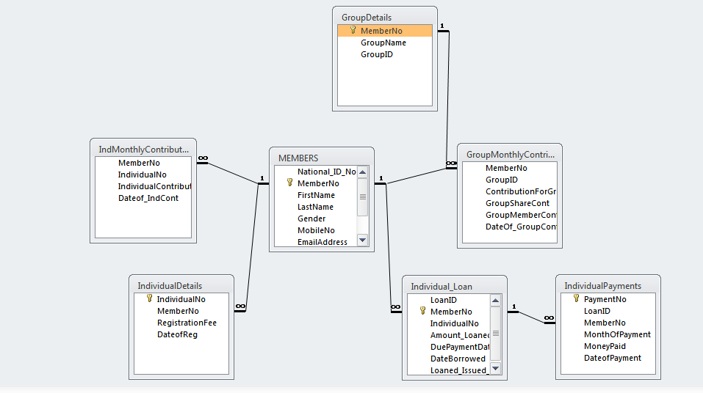

**Figure 13: Relationships**

## Process specifications

These are the operations that system is required to perform.

* To enter and maintain all records of the member in the organization.
* To enter the registration fees of each member and group and compute the total fees paid.
* To enter new monthly contributions for the members and compute each member’s total contributions.
* To enter and maintain records of loans borrowed.
* To compute the loan repayments and interest on the loans borrowed.
* To compute total income of the organization.
* To calculate the amount of dividend required to be given to each shareholder.

## Output specifications

This is what is expected to be displayed by the user .The system should:

* Generate a list of all members in the organization.
* Generate a list of total monthly contributions made by each member.
* Display the amount of loan borrowed by a member or a group.
* Generate reports on the payments made for the loans borrowed or those payments made for the penalized defaulted amounts.
* Generate a report of the income of the organization.
* Display the dividends of each shareholder.

### Tables

These are where all the data in the system is stored for reference and manipulation. They are the basic foundation of the information system.

The following are the tables that were used in the design of the system:

1. Members Table

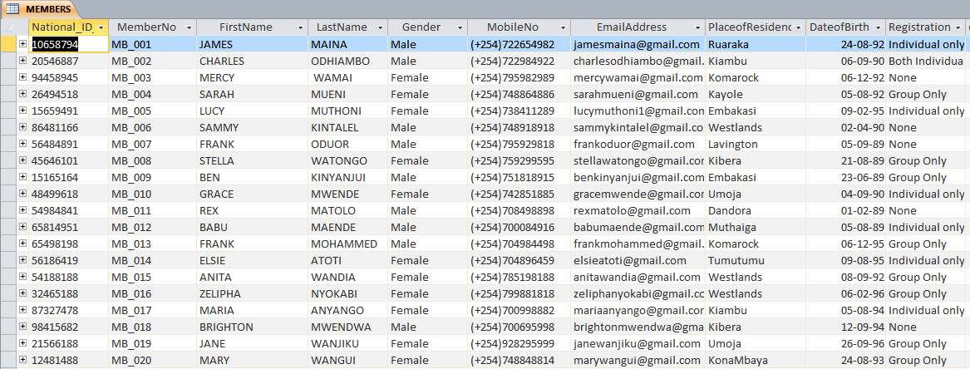

Figure 14: Members Table

1. Individual Details Table

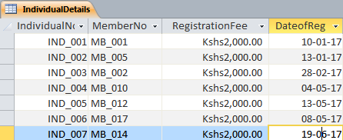

Figure 15: Individual Details Table

1. Groups Table

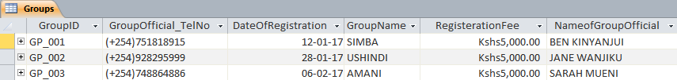

Figure 16: Groups Table

1. Group Members Table

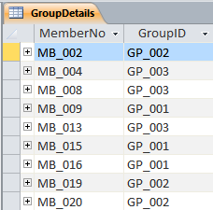

Figure 17: Group Members Table

1. Individual Members Monthly Contributions Table

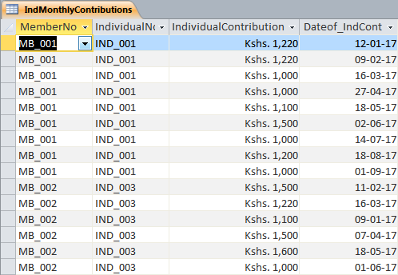

Figure 18: Individual Members Monthly Contributions Table

1. Group Members Monthly Contribution

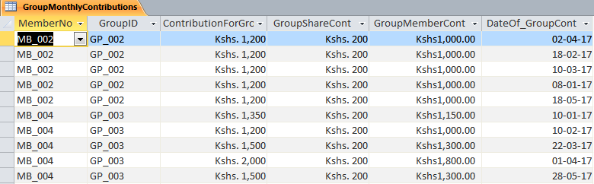

Figure 19: Group Members Monthly Contributions Table

1. Individual Member Loans Table



Figure 20: Individual Member Loans Table

1. Group Member Loans Table

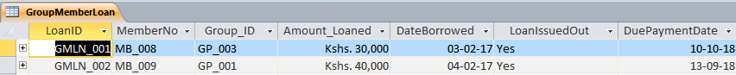

Figure 21: Group Member Loans Table

1. Group Loan Table



Figure 22: Group Loans Table

1. Individual Members Payments Table

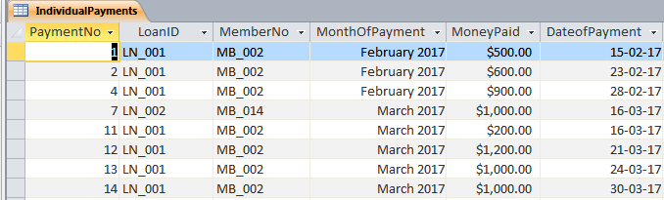

Figure 23: Individual Members Payments Table

1. Group Member Payments Table

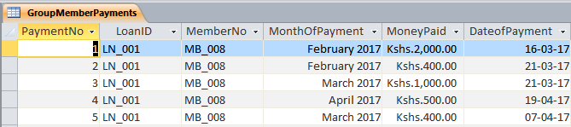

Figure 24: Group Member Payments Table

1. Group Payments Table

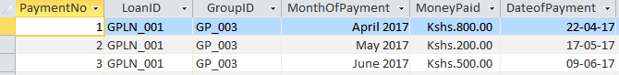

Figure 25: Group Payments Table

1. Individual Member Defaulted Payments Table

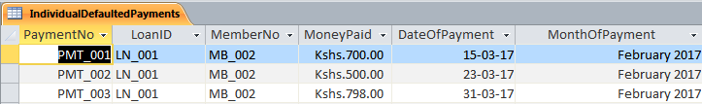

Figure 26: Individual Member Defaulted Payments Table

1. Group Member Defaulted Payments Table

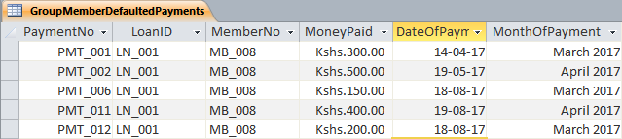

Figure 27: Group Member Defaulted Payments Table

1. Group Defaulted Payments Table

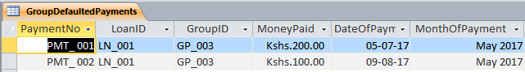

Figure 28: Group Defaulted Payments Table

1. Users Table

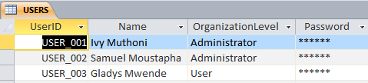

Figure 29: Users Table

### Input Screens/Forms

Input forms are required for easy entering of data in the system and are very crucial to the developing for the system due to their efficient user interface.

The following are the forms that were used in the design of the system:

1. Log in Form

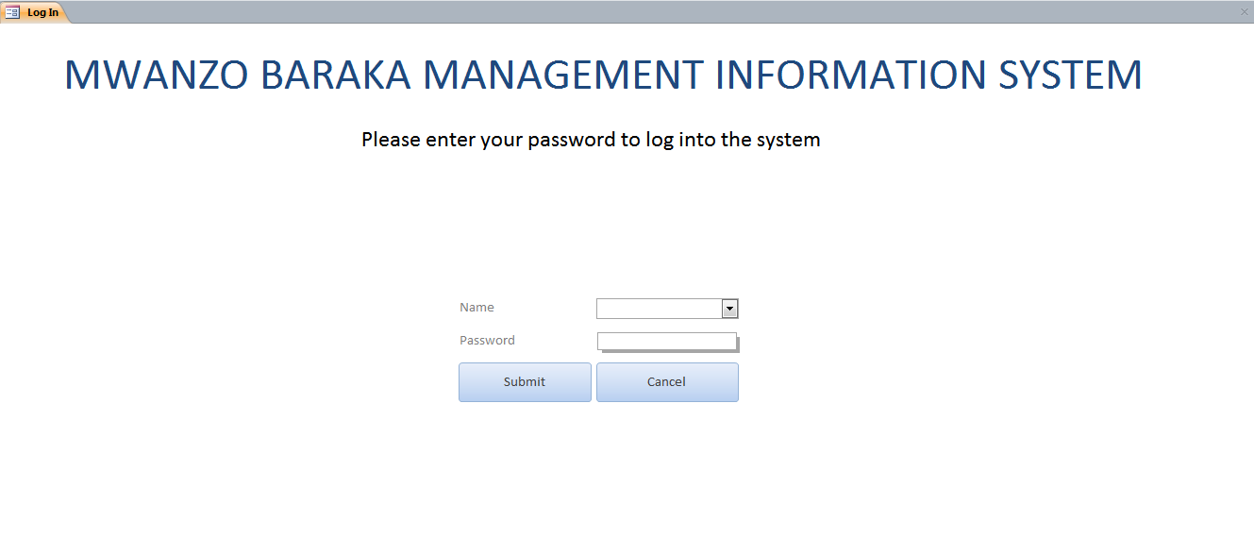

Figure 30: Log in Form

1. Splash Form

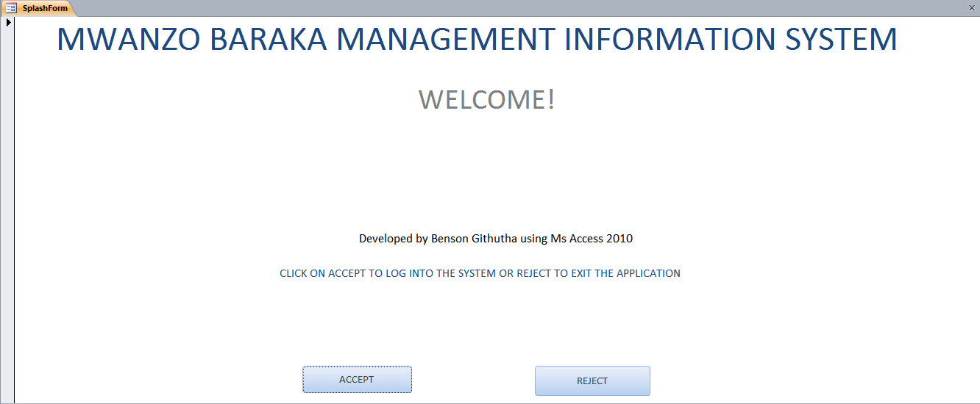

Figure 31: Splash Form

1. HOME-Switchboard

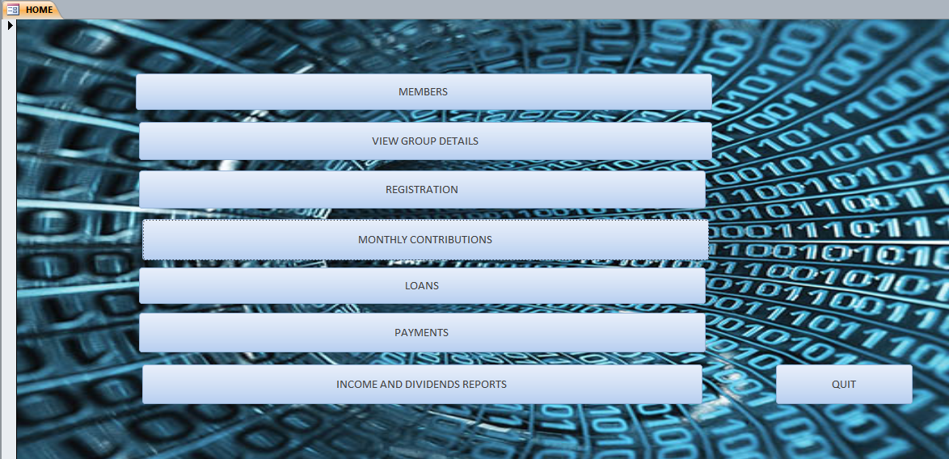

Figure 32: Switchboard

1. Members Form

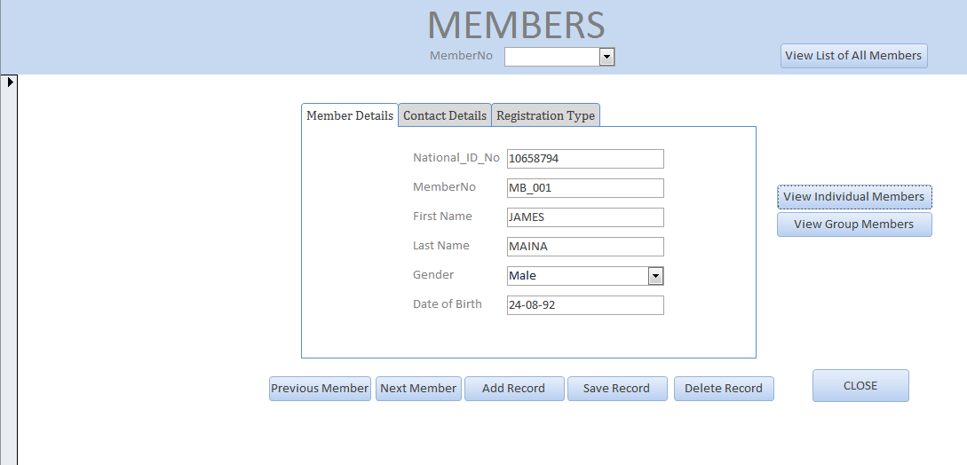

Figure 33: Members Form

1. Group Members Form

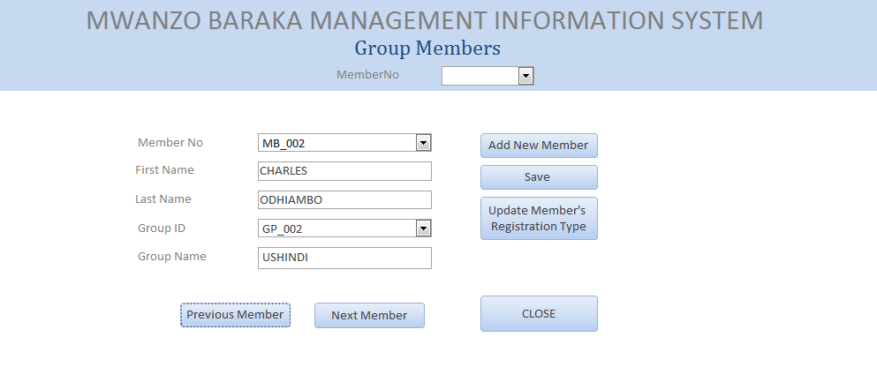

Figure 34: Group Members Form

1. Group Details Form

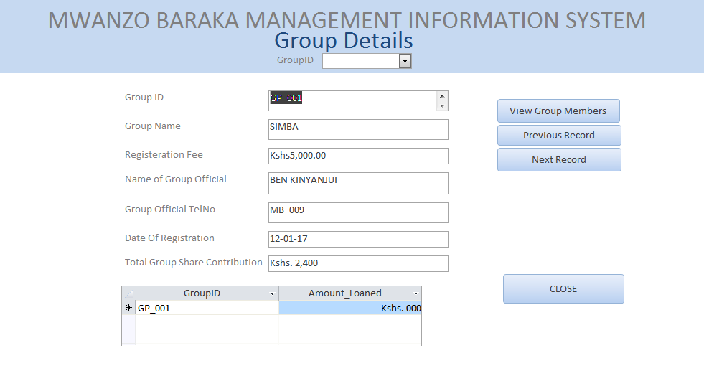

Figure 35: Group Details Form

1. Individual Registration Form

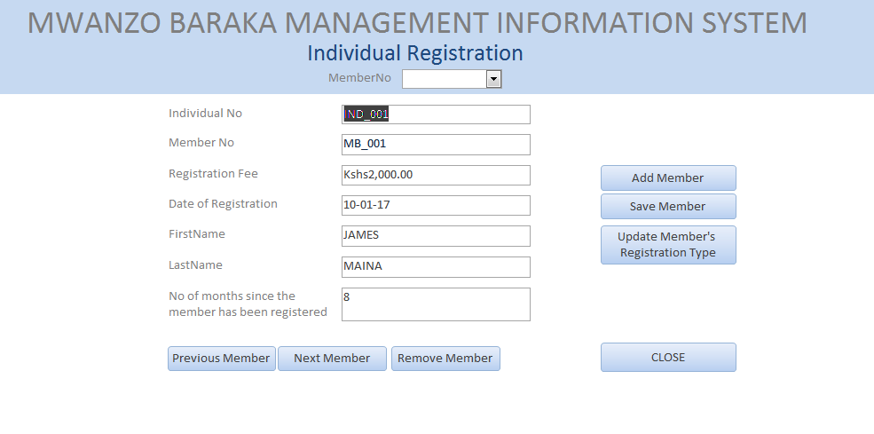

Figure 36: Individual Registration Form

1. Group Registration Form

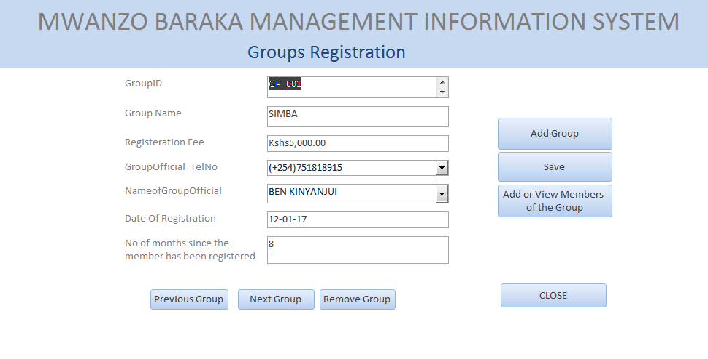

Figure 37: Group Registration Form

1. Individual Monthly Contributions Form

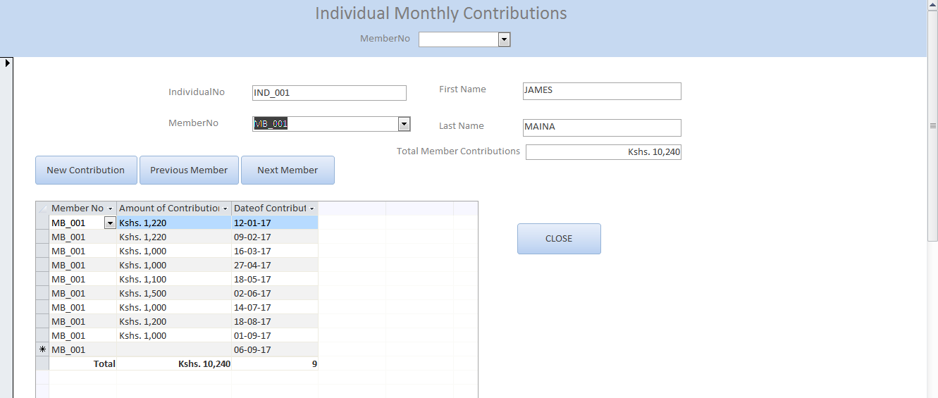

Figure 38: Individual Monthly Contributions Form

1. Group Member Monthly Contributions Form

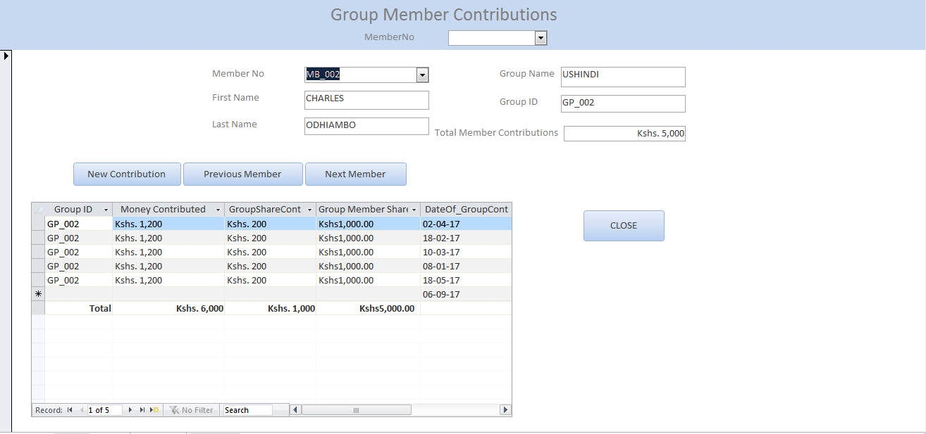

Figure 39: Group Member Monthly Contributions Form

1. Group Share Contributions Form

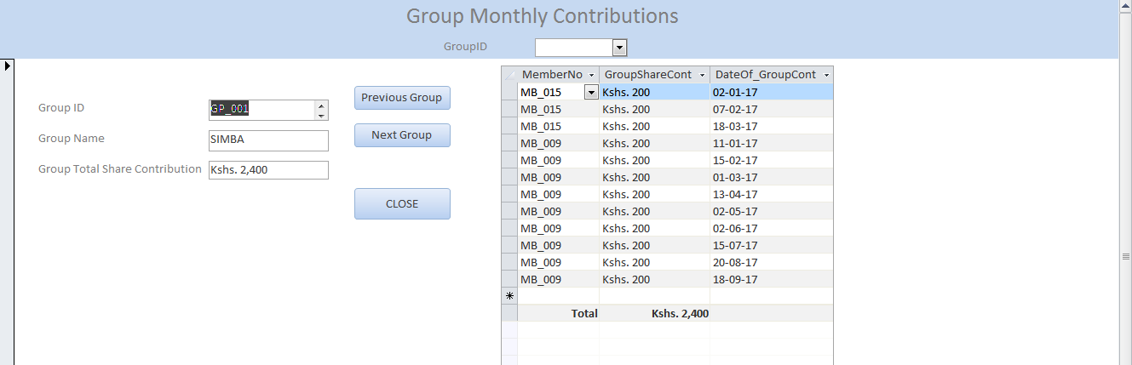

Figure 40: Group Share Contributions Form

1. Individual Loan Form

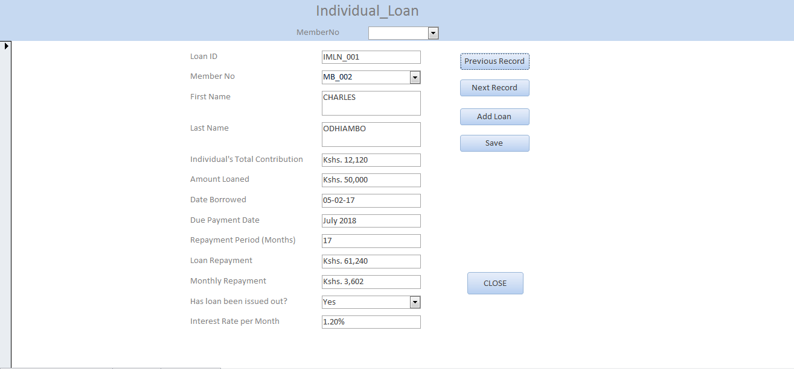

Figure 41: Individual Loan Form

1. Group Member Loan Form

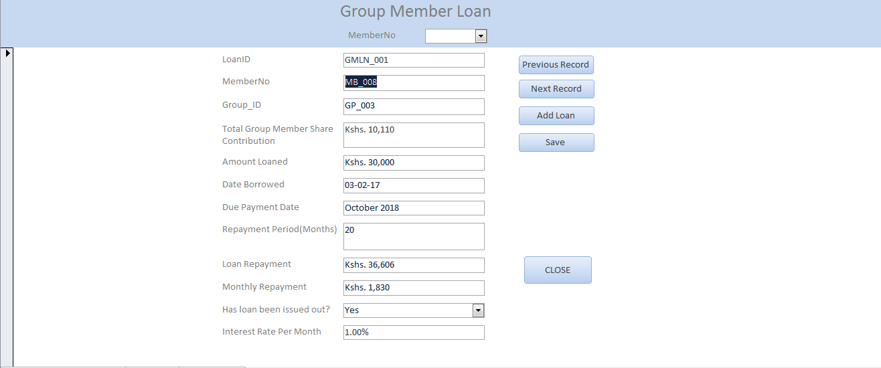

Figure 42: Group Member Loan Form

1. Group Loans Form

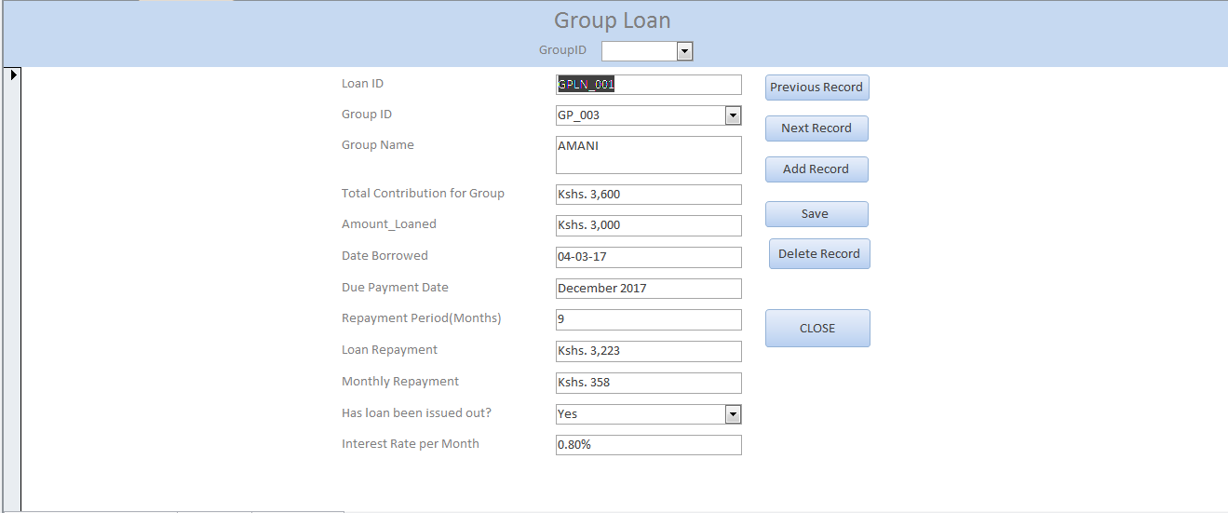

Figure 43: Group Loans

1. Individual Payments Form

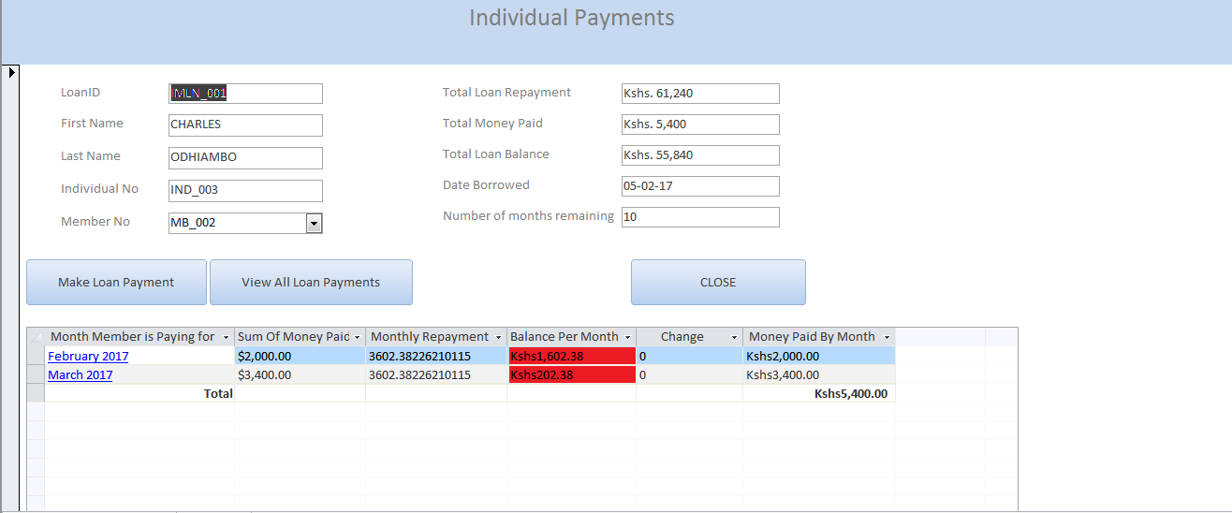

Figure 44: Individual Payments Form

1. Group Member Payments Form

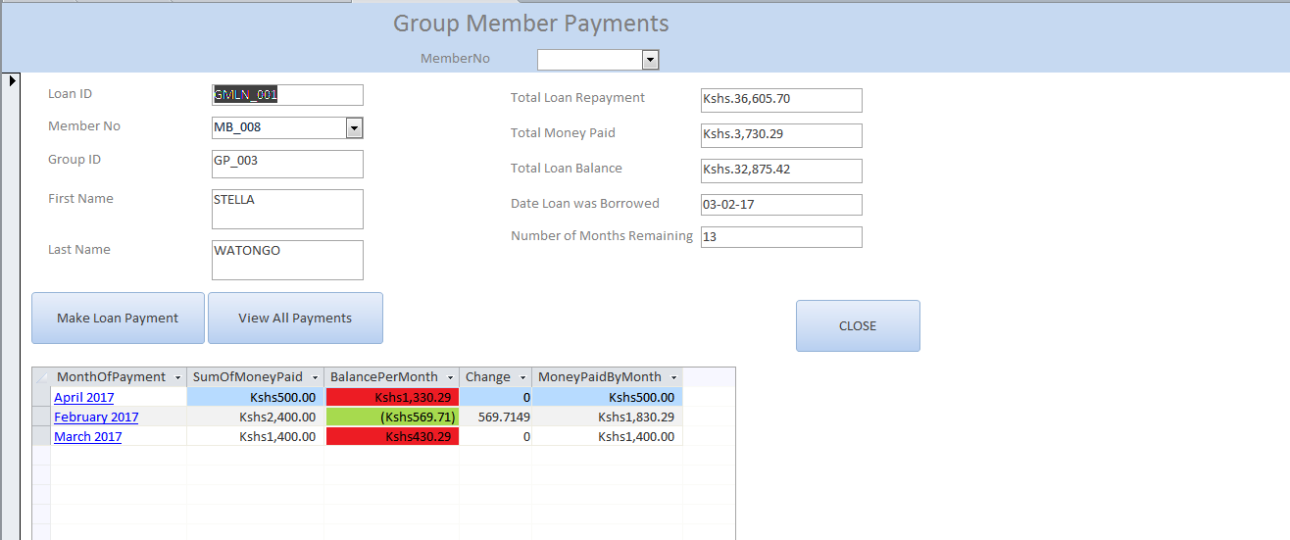

Figure 45: Group Member Payments Form

1. Group Payments Form

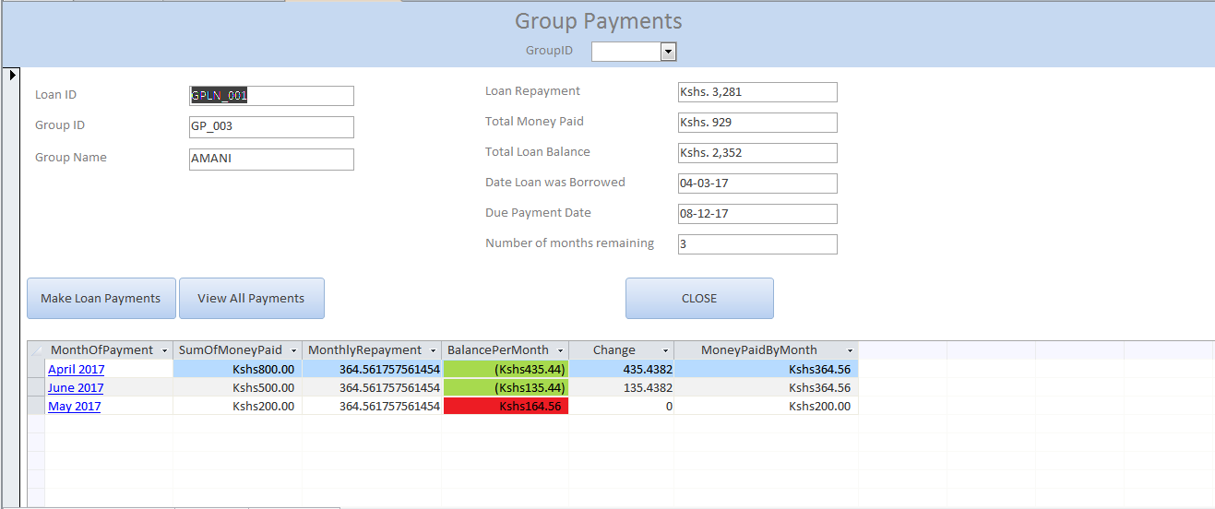

Figure 46: Group Payments Form

### Output Screens

These are the displays for the information required by the user e.g. receipt statements. They are in form of reports.

1. Members Report

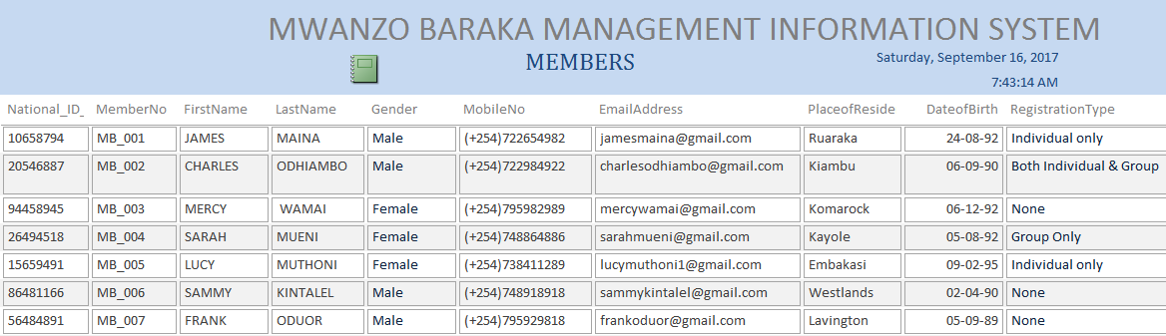

Figure 47: Members Report

1. Individual Members Monthly Contributions Report

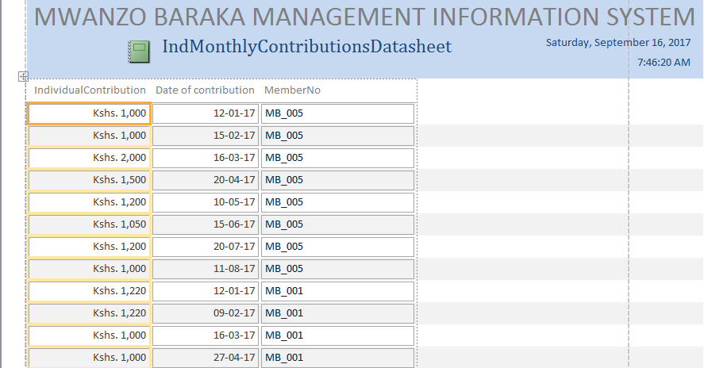

Figure 48: Individual Members Monthly Contributions Report

1. Individual Members Loans Report

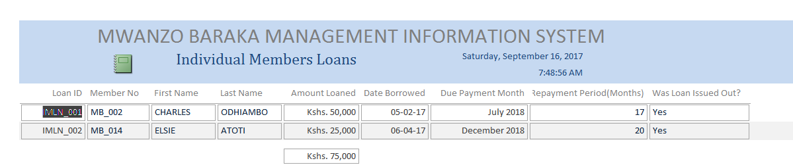

Figure 49: Individual Members Loans Report

1. Individual Members Payments Report

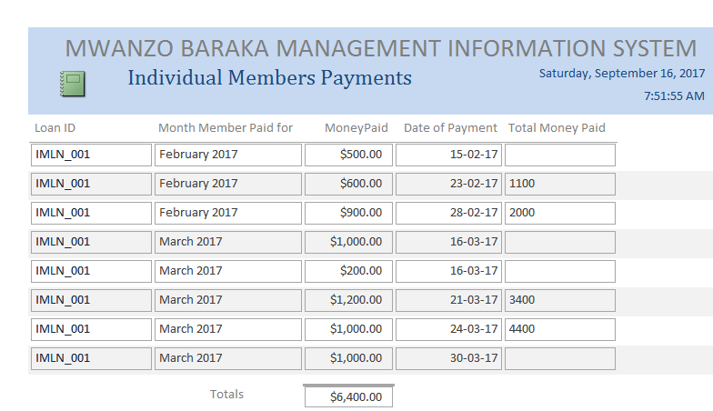

Figure 50: Individual Members Payments Report

# CHAPTER FOUR: SYSTEM TESTING AND DEMONSTRATION

## Objectives of the testing

* To ensure there are no errors in calculation of interests, payments and dividends and therefore enhancing accuracy of the output.
* To minimize redundancy of records.
* To ensure that the new system is user friendly.

## Data Testing Approaches

The system was tested out:

### By Dry Running

I ran through the system manually and wrote the code after noting down some errors in the system.

### By Use of Compilers

Some errors were still found after when I was done coding. I used the compilers to find and correct any logical and syntax error.

### By Use of Test Data

Efficiency was very key in my objectives and therefore I had to ensure that there would be no error in the system. Therefore I opted for the use of test data and trial runs and after getting accurate and correct result, I was satisfied that the system is efficient.

### By Use of Actual Data

The researcher entered the organization’s records into the system and the calculations were carried out automatically. The results were accurate therefore proving the system to be efficient.

## Data Validation Approaches

The approaches used were Black Box testing and White Box testing.

### Black Box Testing

Black box testing is the software testing method which is used to test the software without knowing the internal structure of the system.

### White Box Testing

White box testing is the software testing method in which internal structure is being known to tester who is going to test the system.

## Data testing plan

**Testing text Data Type**

|  |  |  |  |  |
| --- | --- | --- | --- | --- |
| **Field** | **Input** | **Expected results** | **Remarks** | **Passed?** |
| National_ID | 10658794 | Accepted | Valid | Yes |
| MemberNo | MB_001 | Accepted | Valid | Yes |
| MobileNo | 0733za6767 | Rejected | Valid | No |

**Table 28**: **Testing text Data Type**

**Testing Date/Time Data Type**

|  |  |  |  |
| --- | --- | --- | --- |
| **Data entered** | **Expected** | **Remarks** | **Test Passed?** |
| 568AD | Rejected | Invalid | Yes |
| 10456 | Rejected | Invalid | Yes |
| 8th May 2017 | Accepted | Invalid | No |
| 8/9/06 | Accepted | Valid | Yes |

**Table 29: Testing Date/Time Data Type**

**Testing Currency Data Type**

|  |  |  |  |
| --- | --- | --- | --- |
| **Data entered** | **Expected** | **Remarks** | **Test Passed?** |
| Kshs.200m | Rejected | Invalid | Yes |
| 231321 | Accepted | Valid | Yes |
| 234324/46/4646 | Rejected | Invalid | Yes |

Table 30: Testing Currency Data Type

# CHAPTER FIVE: USER MANUAL

This involves the:

* Installation of the System
* Assigning of privileges to users.

## Hardware Specifications

The system requires the following to function effectively:

* At least 512 MB RAM.
* 1 GHz processor speed and above.
* At least 80 GB Hard disk capacity.
* A compatible DVD Drive.

## Software Specifications

* An operating system of either Windows XP, Vista or Windows 7/8. (Works on both X 32 and X64 bit)
* A database management system of Microsoft 2010 onwards (Cannot work on earlier Versions).
* Microsoft Visual Basic 6.0 (for coding and development of the system)

## System loading and installation process

The person installing should have administrator privileges and should ensure the following:

* Ensure that the computer has a functioning CD/DVD drive.
* Ensure that the computer meets the hardware and software requirements as stated above.
* He or she should then insert the disk with the system into the CD/DVD drive.

**Steps**

1. Run the computer in the appropriate operating system.
2. Click on the start button and go to My Computer.
3. Click to open it and select the CD drive.
4. Select “MWANZO BARAKA INFORMATION SYSTEM”.
5. Copy the database file to the desktop of your computer

## System loading process

1. Double click to open.
2. Click on the ‘Accept’ button on the Splash Form.
3. Enter database password as assigned in the user manual i.e. “**mwanzo**”.

**NB:** Type the password, which if correct will log you in, but if false you will remain at that stage until you provide the password or quit the system.

## Navigation guide

1. After login and, a form named “HOME’ will appear.
2. From here, there are options to:

* Record new members in the organization using forms or view a list of them through reports. From the “MEMBERS” form, you can view those who are registered as Individual Members or Group Members or view a list of each of them through reports.
* View all group members using the “GroupMembers” form or all groups through the ‘Group_Details’ form or a list of the groups through reports. You can also view the members of each group through a dialog form called “GroupMembers” or view a list of them through reports.
* Register new Individual members and groups. In the “Groups_Registration” form, you can record the members of the group using forms.
* Add new contributions to the organization either as an Individual Member or a Group Member. You can also view the contributions made by each through reports. Moreover, you can view the group share contribution of each group member using the “GroupMonthlyContribution” form.
* Add new loans or view existing loans either for an individual member, group member or group.
* Make normal loan payments or payments for penalized defaulted amounts for either an individual, group member or group loan. You can also view a list of the payments through reports.
* View total share contributions and dividends for the shareholders.

1. Tables are made purposely to store data.
2. Data is only inputted through forms specially designed for that purpose.
3. Reports are generated to give a list of people, contributions or payments in the database and can be printed. Invoices and cash receipts are also in form of reports.
4. If you wish to exit the system click the “Quit” button on the “Home” form.

**Ending the program**

1. Save all the changes made to the records.
2. Close all forms and reports open in the system.
3. On the “HOME” form click on the “QUIT” button.

## Procedure for generating output

The various modes of displaying information are:

Command buttons have been provided for switching into various forms and reports.

The user has the ability to print the data stored in the reports. One should have a printer installed to do so.

## System security and control measures

The new system has put in place the following control measures to ensure data security:

* Use of passwords which prevent unauthorized access into the system.
* The system cannot be accessible to strangers or even the clients themselves.
* Setting of user privileges, modification levels and restrictions to ensure that data is only entered in an official way.
* Presence of different users and administrators to the system.
* The software is copyrighted.

For security, the user of the computer is supposed to carry out the following:

* Scan the computer first for viruses before running the system.
* Locking the computer room containing the system when not in use.
* Obtaining a UPS for the computer to regulate the power in.
* Logging off the system after use.
* Changing the password at frequent intervals.
* Safeguarding of the components of the computer

## System changeover

This is an implementation technique where the new Information System is installed and the users trained to use it. The types of system changeover are:

**Direct Changeover**

This is where the old system is discarded and a new system introduced immediately.

**Phased Changeover**

This is where a new system is introduced in phases until when the system is completely implemented or installed.

**Parallel Changeover**

This is where the new and the old system are used concurrently until the new system is found to be efficient and the old new system is then discarded.

**Pilot Changeover**

This is where a system is introduced first in one branch or department of the organization and the running of the system is observed keenly by the administration before being introduced in the other branches.

## Error handling

The system handles errors in the following ways:

* It doesn’t accept data of invalid data types.
* It gives corrections to users on how to correct their errors using the Validation text.

# CONCLUSION

This new system will be of great advantage to the Mwanzo Baraka Organization. It will raise the organization’s standards and enable it to be among the best organizations and Sacco’s dealing with issuing out of cheap loans to its members because it does not charge large interests and penalties like the banks. Aside from that, the secretaries’ work has been lessened by 100% as the organization’s system is fully computerized.

# RECOMMENDATIONS

The following modifications are recommended to be implemented in the system:

* Advanced security measures can be used to protect stored data from malicious people. Examples of such measures are fingerprint reading and use of CCTV cameras.
* Modifying of the user-interface to make the best screen appearance.
* Use of up- to-date antivirus so that viruses cannot have a hidden access into the system’s files.

The system cannot, however be modified without prior permission from the System Developer or the System Administrator.

# BIBLIOGRAPHY

In order to develop the system, I used various sources to get some guidance in the construction of the system. The following are the sources that I used in getting assistance:

1. Longhorn Computer studies Form3 & 4 textbook.
2. Log On Computer Form 3 & 4 textbook.

# APPENDICES

## APPENDIX I: SYMBOLS USED

The following is a table that shows the symbols used in the various flowcharts and their meanings;

|  |  |  |
| --- | --- | --- |
| Symbol | Name | Meaning |
|  | Arrow | Direction of logic flow. |
|  | Rectangle | Indicates a Process |
|  | Decision box | Selection of options that suit the user |
|  | Parallelogram | Input or output |
|  | Magnetic disk | Updates and accesses a file in a magnetic disk |
|  | Document | Indicates a form or a report. |
|  | Oval | Indicates the beginning or end of the flowchart. |
|  | Keyboard | Indicates the keying in of data. |

Table 31: Flowchart symbols

## APPENDIX II: DEFINITION OF TERMS

These are the definitions of the technical terms used in the design and construction of the system:

**Flowchart**- is a diagrammatic representation of the overall functionality of a system used in system design.

**In Coding**

These are some of the prefixes used in naming of controls during coding. They are internationally accepted.

|  |  |
| --- | --- |
| Txt | Textboxes e.g. txtFirstName |
| Frm | Forms e.g. frmMembers |
| Rpt | A report e.g. rptIndividualDetails |
| Cmd | Command box e.g. cmdclose |
| Msgbox | Message Box e.g. msgbox “What is your name?” |
| Cbo | Combo box e.g. cboname |

Table 32: Prefixes of controls

**Programming**- is the writing of instructions to be followed by the system during execution.

**System**- is a major component consisting of smaller sets of components which work to achieve a common goal.

## APPENDIX III: SYSTEM CODING

Private Sub MonthOfPayment_Click()

On Error GoTo MonthOfPayment_Click_Err

If (MsgBox("Do You Want To View Normal Payments for Loan ?", 4) = 6) Then

DoCmd.OpenForm FormName:="IndPaymentsSubform", WhereCondition:="MemberNo = '" & Me.MemberNo & "' AND MonthOfPayment = '" & Me.MonthOfPayment & "'", DataMode:=acFormReadOnly, WindowMode:=acDialog, View:=acFormDS

Else

If (MsgBox("Do You Want To View Payments for Penalized Amount ?", 4) = 6) Then

DoCmd.OpenForm FormName:="IndividualDefaultedPaymentsSubform1", WhereCondition:="MemberNo = '" & Me.MemberNo & "' AND MonthOfPayment = '" & Me.MonthOfPayment & "'", DataMode:=acFormReadOnly, WindowMode:=acDialog, View:=acFormDS

End If

End If

MonthOfPayment_Click_Exit:

Exit Sub

MonthOfPayment_Click_Err:

MsgBox Error$

Resume MonthOfPayment_Click_Exit

End Sub

Private Sub MonthOfPayment_Click()

On Error GoTo MonthOfPayment_Click_Err

If (MsgBox("Do You Want To View Normal Payments for Loan ?", 4) = 6) Then

DoCmd.OpenForm FormName:="IndPaymentsSubform", WhereCondition:="MemberNo = '" & Me.MemberNo & "' AND MonthOfPayment = '" & Me.MonthOfPayment & "'", DataMode:=acFormReadOnly, WindowMode:=acDialog, View:=acFormDS

Else

If (MsgBox("Do You Want To View Payments for Penalized Amount ?", 4) = 6) Then

DoCmd.OpenForm FormName:="IndividualDefaultedPaymentsSubform1", WhereCondition:="MemberNo = '" & Me.MemberNo & "' AND MonthOfPayment = '" & Me.MonthOfPayment & "'", DataMode:=acFormReadOnly, WindowMode:=acDialog, View:=acFormDS

End If

End If

MonthOfPayment_Click_Exit:

Exit Sub

MonthOfPayment_Click_Err:

MsgBox Error$

Resume MonthOfPayment_Click_Exit

End Sub